***This packet is to help you once you have completed your experiment and you need to look at your results, discussion and conclusion!***

1. ***Analyze Your Results:*** When you complete your experiments, examine and organize your findings. Use appropriate graphs to make ‘pictures’ of your data. Identify patterns from the graphs. This will help you answer your testable question. Did your experiments give you the expected results? Why or why not? Was your experiment preformed with the exact same steps each time? Are there other explanations that you had not considered or observed? Were there experimental errors in your data taking, experimental design or observations? Remember, that understanding errors is a key skill scientists must develop. In addition, reporting that a suspected variable did not change the results can be valuable information. That is just as much a ‘discovery’ as if there was some change due to the variable. In addition, statistically analyze your data using the statistics that you can understand and explain their meaning.
2. ***Draw Conclusions:*** Did the variable(s) tested cause a change when compared to the standard you are using? What patterns do you see from your graph analysis that exist between your variables? Which variables are important? Did you collect enough data? Do you need to conduct more experimentation? Keep an open mind — never alter results to fit a theory. If your results do not support your hypothesis, that’s ok and in some cases good! Try to explain why you obtained different results than your literature research predicted for you. Were there sources of error that may have caused these differences? If so, identify them. Even if the results do differ, you still have accomplished successful scientific research because you have taken a question and attempted to discover the answer through quantitative testing. This is the way knowledge is obtained in the world of science. Think of practical applications that can be made from this research. How could this project be used in the real world? Finally, explain how you would improve the experiment and what would you do differently.

Data and Data analysis

Your data tables and graphs must be appropriate and created on the computer. We will be using Word in class to make data tables for labs and experiments and a free online program (see picture below) to make graphs. You are welcome to use the same things for your science fair project. If you are comfortable using Excel or another program, feel free to use that instead.

Remember, there are short videos on our class resource website that I have made for you that show you the basics of using these programs to make data tables and graphs.

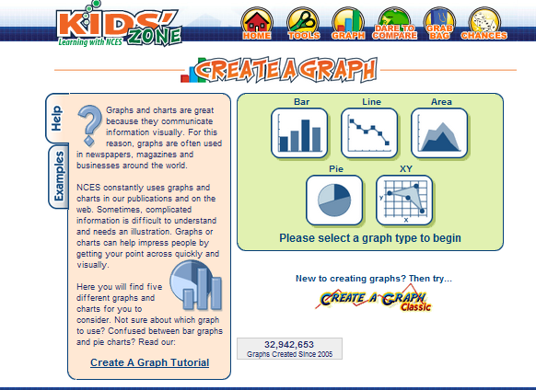

In addition to your data tables, calculations and graphs, you should have a discussion section. You can combine it with your data since you’ll be referring to your graphs and data tables. Basically, you should use the discussion section to point out key features of your results and data. If there are trends that the reader should notice, here is where you should discuss them. If you were talking to someone while they were looking at the graph, what types of things would you say to them? This is separate from your conclusion since this isn’t going to address things like the hypothesis. You should have at least a paragraph of writing for the discussion.

**C:\Users\Jess\AppData\Local\Microsoft\Windows\Temporary Internet Files\Content.IE5\IF8D2PAR\MC900238395[1].wmf**

*Do not use these in science class.*

*Check out the better terms to use*

*as alternatives.*

|  |  |
| --- | --- |
| **DEAD WORDS** | **ALTERNATIVES** |
| **PROOF** | Evidence, Support |
| **PROVE** | Support, Provide evidence |
| **TRUTH / TRUE** | Valid, supported, evidence-based |
| **RIGHT / WRONG**  *(when making or discussing a conclusion to an investigation)* | Valid, supported, evidence-based |
| **CORRECT ANSWER**  *(when making or discussing a conclusion to an investigation)* | Valid, supported, evidence-based |

**Examples:**

**C:\Users\Jess\AppData\Local\Microsoft\Windows\Temporary Internet Files\Content.IE5\IF8D2PAR\MC900238395[1].wmf**

**BAD 🡪**The hypothesis was right. The plants grow taller in the Miracle Grow soil.

**https://encrypted-tbn3.google.com/images?q=tbn:ANd9GcSJVETOQg1z2oM5F3UPW7hXcIwtyHRVAR7JKMHnlHnrYwt3mfbCJQ**

**GOOD 🡪** The data supports the conclusion that the Miracle Grow soil helps plants grow taller.

**C:\Users\Jess\AppData\Local\Microsoft\Windows\Temporary Internet Files\Content.IE5\IF8D2PAR\MC900238395[1].wmf**

**BAD 🡪**The purpose of the experiment is to prove that the Miracle Grow soil makes plants grow taller.

https://encrypted-tbn3.google.com/images?q=tbn:ANd9GcSJVETOQg1z2oM5F3UPW7hXcIwtyHRVAR7JKMHnlHnrYwt3mfbCJQ

**GOOD 🡪** The purpose is to investigate how the type of soil affects the growth of plants.

**Having trouble with how to word some of your conclusion?? Here is a start!**

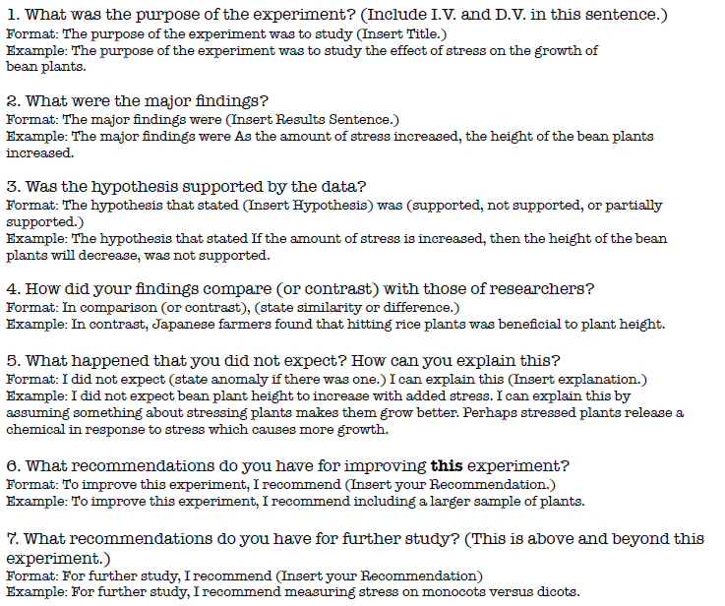

**How do I write an Abstract?**

Once the research is **completed** and you are ready to show your project at the fair, follow these directions to write a draft of the abstract.

***Purpose*** of the experiment (two to three sentences, can incorporate hypothesis into this if you want)

* + An introductory statement of the purpose for investigating the topic of the project.
  + A statement of the engineering problem or hypothesis being studied.
  + **CHECK**: Is the goal(s) stated clear and unambiguous? Is the intended research/experimental design explicit?

***Procedure***(two to three sentences …NOT THE NUMBERED STEPS..keep it conversational )

* + A summarization of the key points what was measured, and how.
  + **CHECK:** Are the steps or sequence clear? Did I include any new or improved methods? Did I include which controls were used? Did I make comparisons? Were risks, attrition, adverse events disclosed? Have I included limits of the procedure to avoid blinding of subjects or investigators by over or understating?
  + An abstract does not give details about the materials used unless it greatly influenced the procedure or had to be developed to do the investigation.
  + An abstract should only include procedures done by the student.

***Observations/Data/Results*** (two to three sentences covering what was found)

* + This section should provide key results that lead directly to the conclusions you have drawn.
  + It should not give too many details about the results nor include tables or graphs.
  + CHECK: Are key numerical/statistical trends revealed? Is the outcome assessment well defined? Is the sample size adequate? Are the calculations or analysis appropriate? Are the tests/trials done well stated? If applicable does it explain if no results were found (yet)?

***Conclusions***(three to four sentences or summary paragraph that answers the "so what")

* + You asked a question, you did an experiment, and you did the experiment a second & third time.
  + You recorded your results. Now it is time to write your conclusion.
  + The conclusion, plain and simple, is the answer to your question. It should be clear, concise and stick to the point. Resist the temptation to jump to conclusions.
  + Conclusions (what you learned from the investigation should be described briefly and state whether your hypothesis was supported or not by the data analysis).

**How to meet the word limit?**

* Most authors agree that it is harder to write a short description of something than a long one. Here's a tip: for your first draft, don't be overly concerned about the length. Just make sure you include all the key information. Then take your draft and start crossing our words, phrases, and sentences that are less important than others. Look for places where you can combine sentences in ways that shorten the total length. Put it aside for a while, then come back and re-read your draft. With a fresh eye, you'll probably find new places to cut. Before you know it you will have a tightly written abstract.