Science fair display board
- In addition to your written paper and research notebook, you will need to create a science fair board to communicate your findings from your investigation.
- All information on the board must be completed on a computer and printed out (including data tables and graphs). If you do not have the ability to do this from home, you will be able to stay for after school help and use school computers.
- The visual display on the board is meant to attract attention and provide information.
- Your visual display should challenge onlookers to want to know more about your project.
- Photographs, graphics, and tables, along with the written text should be included.
- A well-thought-out and interesting title can also attract attention.
- Neatness, completeness, and clarity are very important.
- The board and visual display should help you to present your project logically and serves as a prop for you to illustrate what you have done.
- The only thing that has a “place” is the ABSTRACT. It should be on the official form in the lower left-hand corner of your board.

(Your information does not have to follow these sample boards exactly, but make sure there is a logical progression as you move from left to right.)
- Be creative.
- Use color combinations that are pleasing to the eye.
- Arrange the board in several ways before attaching all of your materials.
- Keep background spaces to a minimum. However, do not crowd tightly so that everything seems too packed.
- Double check spelling!
- Keep it simple.
- Make it easy for the judges and others to assess what you have done.
- Have fun and show off your hard work!
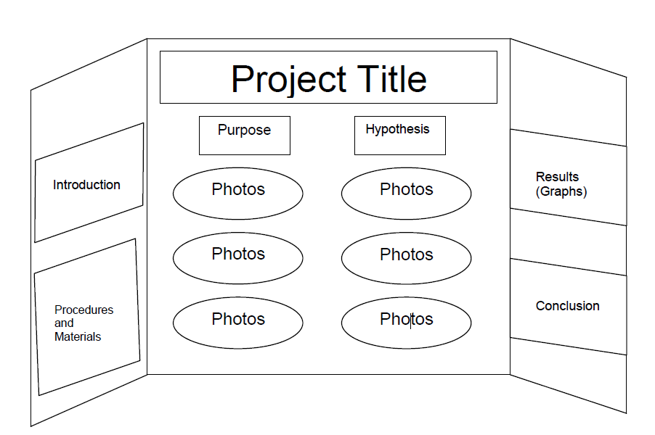
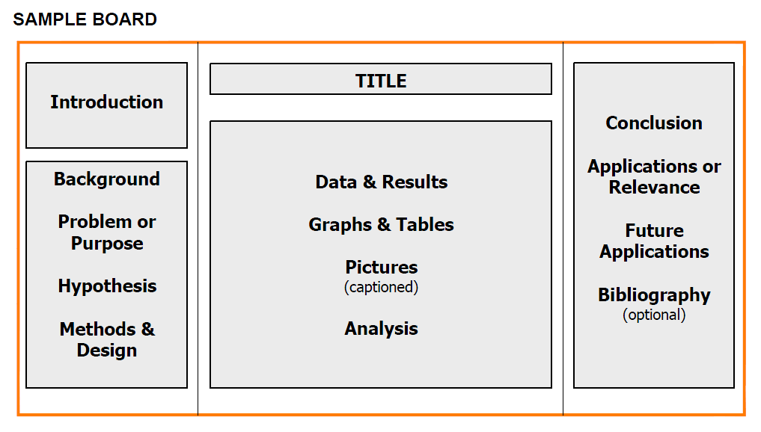

Abstract
Abstract

The day of Science Fair
- Friday, November 15th
- You will come out of class for a few minutes to give your oral presentation to the judges. You only have about 3 minutes to give your presentation and then the judges may ask you questions during or after your presentation.
- We will be giving presentations to the class to practice on the Tuesday, Wednesday and Thursday before Science Fair (November 12th, 13th, and 14th).
- Your grade for the Oral Presentation will come from the presentation that you give in class.
The Oral Presentation
Here is one example of a step-by-step approach to constructing your presentation if you’re unsure:
- Introduce yourself. "Hello, my name is ____________."
- Give the title of your project. "The title of my project is _________."
- Explain the purpose of your project. "The purpose of my project was to _______."
- Tell the judges how you got interested in this topic if you would like.
- Explain your basic procedure. (Don’t try to include every detail.) “The procedure that I followed was _________."
- Show and explain your results. If you have charts, graphs, or a notebook, show them to the judges and explain them. If results are shown on your backboard, point them out.
- Explain what you have shown in your experiment. If you think that you had some problems or error in your experiments, you can talk about that.
- Tell the judges what you might do in the future to continue your experimentation. What would you have done differently if you were to do the project again?
- Of what importance is your project to the world? Explain any applications of your study.
- "Do you have any questions?" If you do not understand the judge’s question, you can ask them to clarify or restate the question. If you don’t know the answer to a judge's question, then say, "I'm sorry, but I don't know the answer, but I think it is ________."
- Thank the judges.

Summary Visual Display for Science Fair:

Eye-Catching – Large lettering & labels with well-labeled
charts & graphs… used striking color combinations

Simple, yet interesting title
- Information organized under headings and in a logical order:
  - Purpose/Problem

Hypothesis
  - Abstract
  - Materials
  - Procedures
  - Results

Conclusions
- Photos of actual experiment or investigation
- Charts & Graphs of Results
- Science notebook (folder or small 3-ring binder with a copy of your written report and paperwork for in front of your board)

Oral Presentation:
- Oral presentation was well-organized and concise
- Spoke with confidence & at an audible level
- Provided clear explanations of research
- Explained what was learned
- Provided clear explanations of results using scientific terminology
- Answered questions about project

